Dear Students,

I am sure you are pracicing graphical representation of linear programming problems.

I am exhibiting here an image of a LPP graph from a book. Please look carefully and try to solve it yourself without looking at the solution given here. The solution in this image has an error.

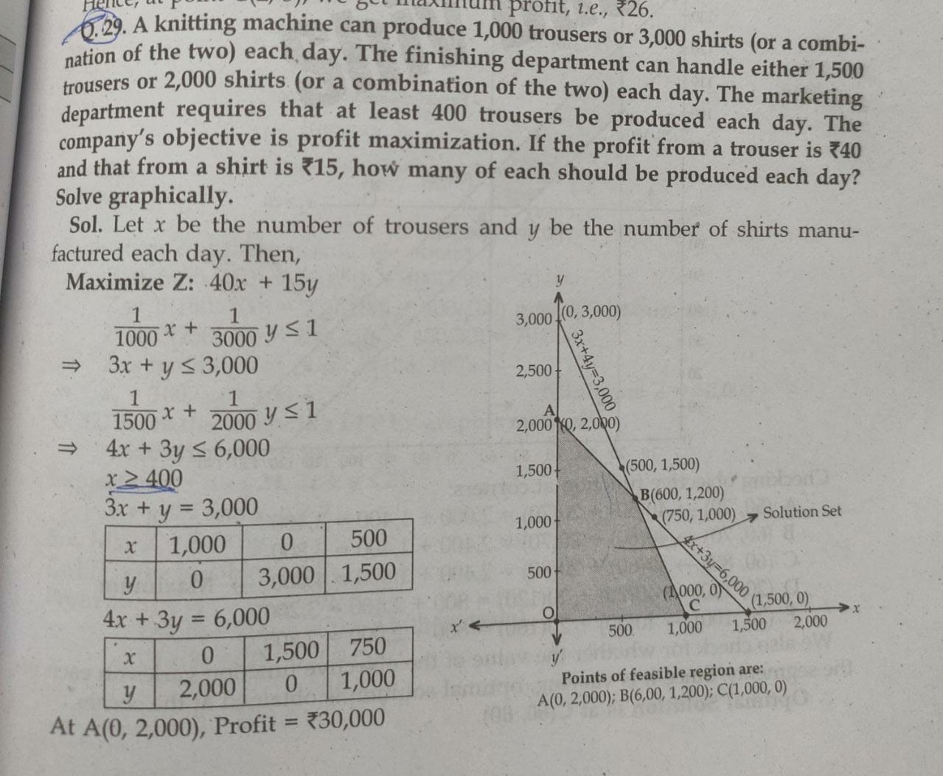

In the above solution, while all other onstraints have been correctly plotted but the constraint

x≥ 400 **has not been plotted**. **As you will plot this constraint the feasible region will change**.A new line starting from the point (400,0) parallel to Y axisshall be plotted.The point E(400,0) will replace point O (0,0)

Point A (0,2000) will no longer be a corner of feasible region. It will be replaced by point F(400,1467).You are requested to find correct graphical solution to the above question.

**Practice questions for graphic method:**

1. A furniture manufacturer has the following resources available. Also given are his requirements for each table and chair he manufactures:

|  |  |  |  |
| --- | --- | --- | --- |
| Resources | Table | Chair | Available |
|  | ( Requirement per unit) | |  |
| Wood 9sq foot) | 30 | 20 | 300 |
| Labour hrs | 5 | 10 | 100 |
| Profit Rs per unit | 60 | 80 |  |

How many tables and chairs should be manufactured to maximize his profit? Use graphic method.

1. In the above question How will the solution change if the following 2 conditions are given :

He has to manufacture at least 2 tables

The number of chairs can not exceed 40

|  |  |
| --- | --- |
| 3. Maximize | *Z = f(x,y) = 3x + 2y* |
| subject to: | *2x + y ≤ 18* |
|  | *2x + 3y ≤ 42* |
|  | *3x + y ≤ 24* |
|  | x ≥ 0 , y ≥ 0 |